L 8. Understanding and building Empathy. Steps towards Empathy
UNDERSTANDING EMPATHY
A11 humans are born with the ability to empathize in varying degrees. According to Roman Kronaric, author of the book Empathy: Why It Matters and How to Get It, our brain is
naturally wired to demonstrate empathy. Human evolution would not have been possible in the absence of mirror neurons' that enabled people to learn from watching others demonstrate their skills.
Iluman skills are passed on through generations with the help of mirror neurons in the brain. Empathy comes naturally to the majority of humans. The greatest of social changes in human history has occurred due to empathy, including the abolition of child labour, slavery and many social ills. Economist Richard Layard argues that the caltivation of the instinct of empathy that leads us to care for other people makes us happier.
If we lack self-awareness, self-regulation and self-motivation, it is unlikely that we can empathize with others. If the inner turmoil of emotions is not well managed, it is rather difficult to understand the emotions of other people. It is needless to mention that true empathy helps build relationships and bond with people in our professional and personal lives. When we communicate with true empathy in an emotionally charged situation, it can lead to a transformative experience.
EXTROSPECTION
Extrospection is an important tool that will help us to gain empathy.
It is the process of examining one's conscious thoughts and feelings.
Acconding to Roman Krznaric, focus during the last century has been predominantly on self-help through the process of introspection.
Extrospection is the observing and sensing of what is external to you. It is about looking into the outside world, seeing people, things and nature around with sensitivity. Our sensitivity towards understanding others has to be developed. Extrospection is very important if we have to move from individualism' to 'collectivism'.
Most of the conflicts stem from individualism and self-interest.
Our relationships, happiness and harmony would be enhanced if we develop 'extrospection'
Channels of Self-awareness
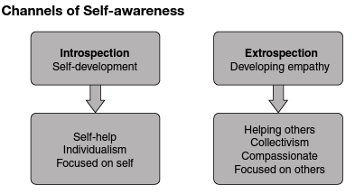

Exercise on Introspection and Extrospection
Think of your thoughts and actions yesterday. List all the thoughts you had about yourself, your family and others.
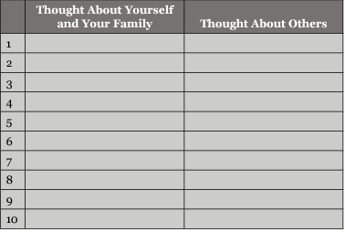
Ratio of Introspection vs Forospection I______: E______
This gives us an indication of whether we are obsessed with self or open for extrospection

BUILDING EMPATHY
EI is constructed over a lifetime based on our learning from the environment. Early development of EI is based on our interactions with parents, teachers, relatives and friends.
Empathy Development
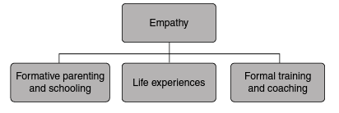
Building El among children at an early age is important as they are more receptive to learning and absorption. The environment at home plays a significant role in building EI in children. If the family environment is devoid of love, affection and compassion, the development of EI could be stunted. Any behavioural change leads to the rewiring of the neuron circuit in the brain. The upbringing of children in the formative ages, especially at an earlier age, plays a significant role in the building of El.
Development of empathy in a child is based on the way the child receives stimulus at a young age. If the child receives love, affection and care during the formative ages, the 'mirror neurons' responsible for empathy are better developed. This makes it imperative for parents to pay due attention to the same.
It is often noticed that children exposed to a disturbed family environment, filled with conflict, aggressive behaviour from parents, have diminished empathy, the effects of which become evident in the later stages of their lives. When we observe children brought up in the streets and slums of major cities, devoid of parental love, affection and guidance, we find that they have a higher chance of turning into criminals, devoid of empathy. They are unlikely to be sensitive to the pain of others as they exhibit violence because their mirror neurons responsible for empathy are underdeveloped.
The lack of empathy is not confined to the lower economie strata of society. It is also prevalent among children from economically well-placed families. Children faced with physical or mental abuse may demonstrate a lack of empathy. Early unpleasant experiences impat their ability to empathize with others when they grow into adults.
All mammals care for and nurture their young ones as an intrinsic part of natural development. Physical touch is a common trait among mammals to demonstrate love and care towards their offspring. In the case of humans, we tend to drift away from this natural process due to the compulsions and pressures of modern life. Ineffective parenting and family environment can severely impact the El of the child.
Other influencers of empathy in a child include parents, grandparents, relatives, teachers and friends. A surprising fact is that a host of subjects are offered by academic intuitions, but hardly any related to right parenting. Young men and women on the verge of entering family life are hardly equipped or educated to raise children. It is left to their conditioned, natural instincts or the process of trial and error.
EMPATHY AND 'MIRROR NEURONS'
V. S Ramachandran, University of California, known as the Marco Polo of neuroscience, highlighted the importance of mirror neurons' in our brains. He pioneered the 'phantom limb' experiment. This research identified the presence of a set of mirror neurons' in the human brain attributed to empathy.
The ability of humans to observe a task being performed by someone else and to learn the skills quickly in a matter of minutes is attributed to the presence of certain clusters of neurons termed as 'mirror neurons. They are called 'mirror neurons' as they mirror the emotions and feelings of other human beings in us.
Mirror neurons' are triggered when we witness other people experience emotions such as pain, joy and sadness. When we watch a game of soccer and a goal is scored by a player at a critical moment in the match, our mirror neurons' momentarily imagine that we have kicked the ball into the goal. At that moment, our legs might actually twitch. These neurons momentarily make us feel exactly the same emotions that we are witnessing. The same is likely to happen when we see other humans demonstrate emotions. It was thus established that mirror neurons' are responsible for empathy in human beings. The more developed the 'mirror neurons' are, the more would be empathy.
When we want to develop our musculature, we exercise regularly to achieve the desired result. Similarly, the human brain is developed over a period of time with repeated practice. It is well known that thoughts and actions are triggered by several thousands of neurons connected by a circuit in the brain. There are 100 billion neurons in the human brain. Each neuron makes about 1,000 to 10,000 contacts with other neurons. The permutation and combination of possible connections in the human brain are estimated to be more than the elementary particles in the universe.
The human adult brain is an astounding mystery. With the understanding of neuroplasticity, we can change the circuits in our brain through repeated practice.
Giacomo Rizzolatti, the Italian neurophysiologist discovered 'mirror neurons' in the frontal lobes of the brain. As V. S. Ramachandran further amplifies, the human brain is a lump of flesh, about three pounds in weight, which can be held in the palm of our hands.
Our brain can actually contemplate the vastness of interstellar space, measure infinity, ask questions about the meaning of its own existence and the nature of the creator. It is truly the most fascinating and mysterious piece of work. There are ordinary neurons called 'motor command neurons located in the frontal lobe, and they are responsible for body motor movements. Each specific physical movement of the body is triggered by a specific set of motor neurons in the frontal lobe.
An option is to study the brain of patients who have lesions in some parts, focusing on the impact of these lesions on brain activity and their bodies. Another option is to plant electrodes in different parts of the brain and eavesdrop on its activities and dysfunctions.
Giacomo Rizzolatti performed experiments on monkeys and discovered that motor neurons were triggered when monkeys performed a set of activities. An important deduction from these experiments was that around 20 per cent of the neurons were fired when monkeys saw other monkeys perform an activity. The same set of motor neurons was triggered in the watchers and the ones engaged in the activity. V. S.
Ramachandran terms these as the 'empathy neurons'.
"Mirror neurons are responsible for the learning and advancement of the human race. All development through the ages has been made possible by mirror neurons'. It is due to these neurons that we can see a person engaged in an activity and quickly learn and own the same. This is an outstanding discovery, as this establishes the superiority of the human race in comparison to any other species in the world.
As mentioned earlier, children devoid of nurturing and right parenting are likely to have less developed 'mirror neurons'. If they have not received empathy, they find it difficult to demonstrate it.
It is the 'mirror neurons that enable us to put ourselves in other's shoes and feel the emotions.
EMPATHY ANTENNAE
In order to develop empathy, we need emotional antennae'. Unless ourbrain senses the pain, the agony, the suffering, the disappointment of others, the feeling of empathy may not be triggered. This process is facilitated by the 'mirror neurons'. If the emotional antennae' are not strong enough, it fails to catch the emotional signals from others.
The sensitivity of the antennae differs from person to person.
TYPES OF EMPATHY
The core skill in social awareness is empathy. It is about sensing what others are thinking and feeling, even when not expressed in words. We continuously send signals about our feelings through our tone of voice, facial expressions, gestures and numerous other nonverbal communications. However, the ability to read these signals in others varies on the basis of our level of empathy.
Types of Empathy
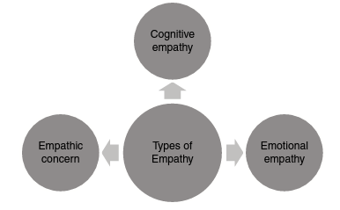
Cognitive Empathy
It is the ability to see things in the way others may think and act, and through which understand their perspective. Leaders with a high level of cognitive empathy inspire their teams to perform better.
They understand others, can put forward their ideas with clarity and thereby succeed in communicating well. This influences the motivation level of the team and effectively helps manage diversity.
Emotional Empathy
This trait enables us to feel for others. This is the basis on which we strike a rapport and establish a connection with other humans.
Those with a high level of emotional empathy are good counsellors, teachers, client managers and group leaders. They can always sense how others are feeling.
Empathic Concern
This is the ability to sense when people are in need of help. The chances of lending help to others increase with this type of empathy.
People with empathetic concern help others voluntarily. They create good team rapport, which in turn enhances their performance.
Empathy is an essential component that leads to compassion, which farther helps build El.
Emotional empathy was studied by Tania Singer, a neuroscientist at Max Planck Institute in Germany. Insula, a fissure that separates the temporal lobe from the parietal and frontal lobes, plays a key role in empathy in humans. It senses signals from all over the body when we empathize with others. Our 'mirror neurons' mimic within us the state of the person experiencing an emotion. The exterior area of insula reads the pattern and tells us the emotional state of the other person.
There are distinct steps towards demonstrating empathy. Understanding these steps would help us practise and be empathetic towards others. Just as for any other skill, repeated practice is a powerful way to develop empathy in us.
STEPS TOWARDS EMPATHY
To effectively display empathy, we must understand the four steps that lead us in that direction. A higher form of empathy is compassion, and these steps will help us to develop the same.
Steps towards Empathy
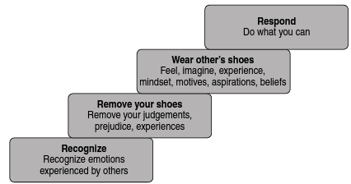
Recognize
The first step is to recognize the emotions of others. It is about having the emotional antenna' to receive signals of emotions experienced by people around us. In the absence of an emotional antenna, we may not be able to sense their emotions. With a weak antenna, we tend to either ignore or be unaware of their emotions. Recognition occurs on the basis of verbal and non-verbal cues.
Remove Your Shoes
The common understanding of empathy is expressed as putting yourself in someone else's shoes. On the contrary, the first step towards empathy is removing one's shoes'. It is unlikely that we can empathize without removing our shoes. We often tend to be clouded by our own opinions, biases and preconceived notions gained out of previous experiences. We are unable to empathize, being imprisoned by our myopic past experiences that suffocate our imaginations and perceptions. Prejudice and judgement further act as an impediment in understanding and capturing emotions in others.
Wear Other's Shoes
With the help of cognitive, emotional empathy and empathetie concern, we must learn how to dive deeply into the person. Wearing the other person's shoes will enable us to view the world and the situation from their perspective. We must develop the capability to experience the pain and suffering of others.
True empathy is not very easy to cultivate. If we master this capability, the resulting experience can lead to a transformative paradigm shift.
More often, we tend to advise, recommend and prescribe on the basis of how we view their situation. Wearing the shoes of others and actually experiencing where it bites could create unique and deeply meaningful relationships.
Respond
Empathy inevitably leads to compassion. A peak of compassion often leads us to a response aimed at relieving pain in others. Thus, the chain of intensity of emotions can be listed as pity, sympathy and empathy followed by compassion. Each of these emotions has varying degrees of utility and effectiveness in our journey towards compassion. When we follow the aforementioned process of empathy, our chances of responding to the needs of others enhance.

Four Steps towards Empathy
Read the short description and relate to the four steps towards empathy.
The environment in the home of the couple Vikrant and Sandhya was not conducive over the last few months. They. had been having conflicts with a heated exchange of words, sometimes all through the night. In fact, the arguments were intense to the extent of being abusive. They had not been on talking terms with each other. Moreover, their work kept them away from each other for long durations. Unfortunately their young daughter was often a witness to their conflicts.
One day, their seven-year-old daughter came up hesitantly to the dining table while they were having dinner.
She said in a shaken and fearful voice, I am not able to sleep alone, I am scared. 1 have bad dreams every day."
At different instances, she expressed her feeling of insecurity in different ways.
"I can't go to school tomorrow as I have not been doing my homework for a month."
With tears rolling down her cheeks, she said, 'I am having sleepless nights. Are you both going to leave me and go away?*
'I dream of being left alone with no one to take care of me.*
Wiping her tears with both her hands, she said, 'No one loves me in this world. No one talks to me anymore.'
She asked, 'Are you both angry with me? Do you love me?
Exercise
What is the emotion that you recognize in the little girl?
__________________________________________________________________________________________________________________________________________________________
Did you remove your shoes? What are the perceptions, experiences and judgement you removed?
__________________________________________________________________________________________________________________________________________________________
Did you wear the shoes of the little girl? Did you feel, imagine the mindset, aspirations and thoughts of the child?
__________________________________________________________________________________________________________________________________________________________
What would be your response to the child if you were the parent?
__________________________________________________________________________________________________________________________________________________________
EMOTIONS LEADING TO COMPASSION
There are various levels of intensity of emotions leading us towards compassion. Showing compassion is a critical component of developing El.
Pity
Pity is an emotion that we experience when we see suffering in others. We usually tend to move on with our lives after momentarily experieneing the emotion of pity. For example, we see someone scantily clad, begging for food on the street as we travel in the comfort of our car. We pity the beggar and drive on.
Sympathy
Sympathy is when pity turns into a physical display of concern with the intent of relieving the pain of others. We might not be aware of the struggle experienced by the other person. Sympathy is trying to
Intensity of Emotions towards Compassion
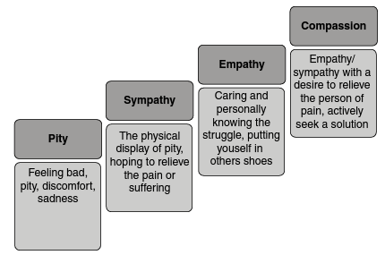
understand the suffering of others. For example, when we get down from the comfort of our car and say a few kind words in order to provide solace to the beggar.
Empathy
Empathy is when we not only sympathize with a few kind words but also display our sympathy physically. We try to understand, to feel the struggle and the painful experience of others. Empathy is deeper than sympathy, as we actually get into the other person. German Psychologist Edward Titchener refers to empathy as Einfühlung, which means feeling into'. We literally get into the psyche of the other person in order to experience their pain and suffering. For example, when we get into the life of the beggar, deeply experiencing the challenges he/she faces on a day-to-day basis, it leads us towards empathy.
Compassion
Compassion is a higher form of emotion that leads us to act towards relieving the person from pain and suffering. When empathy is clubbed with the intent to act, it becomes compassion. Compassion is not a static emotion. It compels us to act or to provide a solution.
When we choose to relocate the beggar to a safe and comfortable place, maybe to an orphanage and relieve him/her of suffering, it is compas-sion. Not all those who experience pity, sympathy or empathy act to provide a solution. It is a stronger emotion as it is clubbed with action.
Think of an example in your life when you experienced the following levels of emotions:
Pity

Sympathy
_____________________________________________________________________________
Empathy
_____________________________________________________________________________
Compassion
_____________________________________________________________________________

